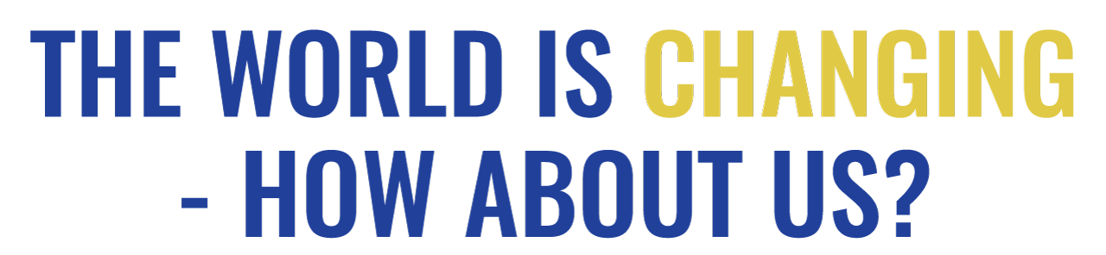
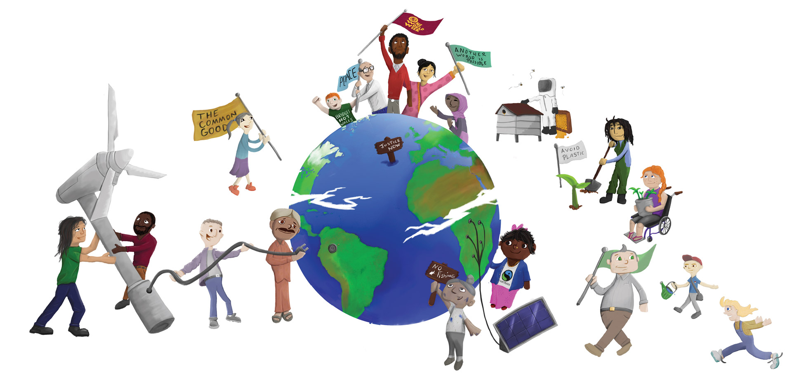

PLEDGES

to help us become activists for change
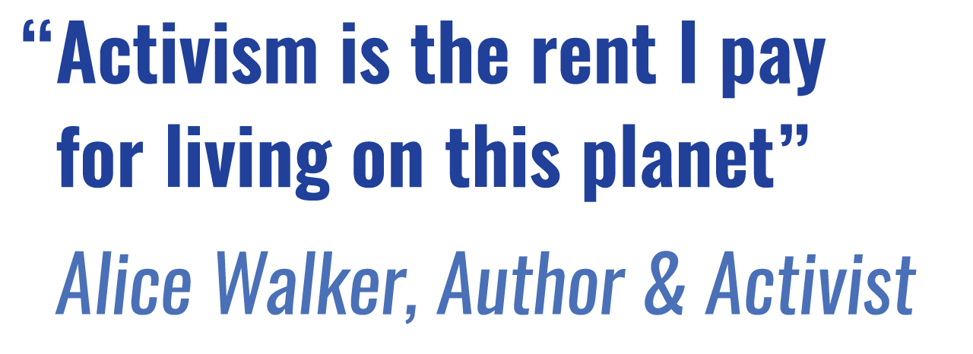

Introduction
How can I use this resource?
You can use these pledges to encourage people to think about what they can do to move beyond the current culture of consumerism and waste towards being more engaged with our families, our neighbours, our local communities, our national affairs and our greater one world family. Humanity cannot afford to continue to consume the planet’s resources at the current rate. Wasteful use of resources is depleting and damaging ecosystems, increasing the rate of species extinction, and driving climate change, and leaving millions of people hungry. But reducing the time and money we spend shopping for the latest fashionable thing, releases us to engage in all sorts of activities that can make our lives more fun and more satisfying and contribute to making our local and global home a better place for everyone.
We need to be aware of our power to make a difference. By taking a stand on eating less meat and using less plastic – and telling people about it we can change our own lifestyle and show other by example what is possible. We can resist the commercial and social pressures upon us to buy more and more stuff which never satisfies us for long, we can instead focus on more rewarding activities that enable us live in greater harmony with each other and with the environment. As we find ways to enhance our lives and the lives of those around us, without damaging the planet we shall also be making a positive contribution to future generations.
You could hold an event about “The World is Changing – How about us?” to start people thinking about how they might change and ask them to making a pledge, or several! You could use them as part of an event - perhaps to round it off with people making a commitment.
To begin an activity, you could use OWWs Discussion Starters Resource.
You could divide into groups to discuss each of these – expand on them, explore why they matter and report back to the whole group.

Or you could start with the Quiz (OWW 2018 Resource) and then encourage people to make some pledges.

There is a an additional set of pledges, ‘OWW Pledges about Plastics’, relating specifically to plastics, which you could cut out. They would work well if you wanted to project them.

More Possible activities :
- You could separate the pledges from the reasons, and ask people to match them back together. To add a competitive element, people could work in teams, with the first team to complete the task correctly winning a small prize.
- Put all of the pledges into a ‘Pledge Box’ and take it in turns to pick one out. Discuss how the pledge could be implemented.
- Draw round a hand to make colourful cards to write your pledge on to symbolise a “hands- on” approach. Join them up to demonstrate how important doing things together is. You can make a decorative wall display or a banner. Or:
- Display your pledges by writing them on strips of brightly coloured paper and linking them together in a ‘Pledges for Change Chain’ that could be displayed in your office, school, place of worship or community centre.
- Or put them (on cards or handprints) on a table for people to choose one that they will take home and try to implement.
- Put your pledge into action and make sure you regularly check how well you are doing. Encourage others to join you and keep each other motivated.

Pledges to change our behaviour to give all our children the chance of a sustainable future on our planet
These pledges cater for a variety of situations, urban, and rural; different age ranges and family roles. There are even some pledges for Book clubs! Not all will be appropriate to everyone. You can select from these or write your own. Think about what is important to you, and how you can play apart in building a world fit for our children to live in.
I pledge to…  Repair or get things repaired where possible rather than replacing them with new. | Why?  Because I’ve had more than enough of the ‘throw away culture”. Making things last longer will reduce the amount of materials going through the system, so reduce the demand for new resources from our already over exploited planet.
I pledge to…  Eat local fruit and vegetables when in season (not forced in fossil fuel heated glass houses) and continue to eat Fairtrade imports too... | Why?  Because local produce uses less energy than goods imported by air. Eating seasonal vegetables helps us to appreciate the changing seasons and local specialities. Supporting your local farmers will reduce food transport costs and keep local traditions and identities alive. (buying Fairtrade will give small-holder farmers in developing countries a secure economic base from which to adapt to climate change and care for their families and their environment. Fairtrade imports often have a lower carbon footprint that local products grown in fossil fuel heated glass houses)
I pledge to…  Ride a bike instead of taking the car when making short trips... | Why?  Because you can reduce your carbon footprint and get some healthy exercise, all at the same time!
I pledge to…  Keep buying Fairtrade products... | Why?  Because buying fairly traded products means a better deal for the producers, which allows them to provide for their families, develop their communities and also to care for their land and adapt to climate change. It sets an example of how trade should treat producers justly
I pledge to…  Write (and print) on both sides of every piece of paper... | Why?  Because it produces less waste so it is kinder to the environment. Deforestation ruins indigenous homesteads and animals’ habitats contributing to species extinction, creating social and environmental instability and threatens to leave future generations without species we enjoy today.
I pledge to…  Eat less meat... | Why?  Because in 2017 an area of forest the size of Italy was destroyed, in large part to clear land for raising cattle destined for human consumption. The majority of trees were felled in the Amazon and the Democratic Republic of Congo.
I pledge to…  Try out a new recipe using local seasonal products every month | Why?  Because my family will enjoy it, local farmers will benefit and we‘ll all appreciate the links between production and the food we eat.
I pledge to...  Support a local food bank | Why?  Because people are hungry here too - they have insufficient income to feed themselves and their families properly, as a result of job losses and benefit cuts.
I pledge to...  Create a place of peace and tranquillity, a garden for myself and others and wildlife to use... | Why?  Because it is good to have somewhere quiet to retreat to when life is too hectic. Opening this space up to others will give them the opportunity to find inner peace and appreciate the natural world.
I pledge to...  To take regular walks in the countryside with friends or family | Why?  Because it’s healthy exercise; also because it is good to appreciate, reflect upon and respect the changing rhythms of the farming and natural world that is our life support.
I pledge to…  Join on-line campaigning groups like 38 Degrees and Avaaz | Why?  Because acting together we CAN change things - I can join my voice with millions of others worldwide to tell politicians and big business what we would like them to do to make the world just and sustainable.
I pledge to…  Tell my local MP what I would like her/him to do to ensure that my community thrives sustainably... | Why?  Because if enough people speak up, change will really happen.
I pledge to…  Support organisations like the Royal Society for Protection of Birds which has projects to protect the habitats of endangered species. | Why?  Because other species are part of the whole natural ecosystem that supports life and diversity makes it resilient. And I want our shared destiny to include tigers and biodiversity for future generations to enjoy.
I pledge to…  Go through my cupboards and eliminate single use plastics | Why?  Because we cannot go on letting plastic waste reach the oceans, devastate marine eco systems and enter the food chain.
I pledge to…  Start a fashion for recycled clothes and use exchange stalls and Charity Shops | Why?  Because I’ve had more than enough of being defined by brand names! It will save money for more important things and it will be a fun challenge to find and refashion them and reduce waste.
I pledge to…  Buy organic goods whenever possible... | Why?  Because other crops are sprayed by highly pollutant insecticides which not only damage bees the environment but the communities around the farming areas. Health, economic and environmental sustainability are key aspects in ensuring lasting peace.
I pledge to…  Turn my television off at the set, and not use the remote to leave it on stand-by... | Why?  Because all that wasted energy is damaging to the environment.
I pledge to…  Buy only wood with the FSC logo on it... | Why?  Because wood consumption is so high that many forests are being illegally logged and valuable ecosystems are being destroyed. This symbol verifies that your wood is from a sustainable source.
I pledge to…  Make compost... | Why?  Because although 60% of household rubbish could be composted, 80% of it is ending up in the local landfill site. As these sites fill up new land must be found to dump waste, which damages the local community and the global environment.
I pledge to…  Switch to a green energy supplier | Why?  Because solar and wind power are sustainable and we need to signal a demand for sustainable energy production to encourage investment in it and divestment from energy production from fossil fuels.
I pledge to…  Turn the tap off when I clean my teeth... | Why?  Many people don’t have access to fresh water, and what the world does have is running out. Some experts think that we will soon be fighting ‘water wars’ because of this shortage, so we shouldn’t waste what we have.
I pledge to...  Spend more time with my children out of doors enjoying and finding out about the natural world | Why?  Because we all need to appreciate and wonder at, not just the beauty, but the complexity of the interactions among the life forms which support us.
I pledge to…  Avoid plastic packaging where possible when I shop: Re-use my plastic carrier bags, or buy a ‘bag for life’... | Why?  Because it will help to limit the amount of plastic bags that end up in landfill sites and the sea, killing helpless birds and marine life.
I pledge to…  try to get my book club to read a book written by someone from a culture other than our own | Why?  Because it would give us an insight into how people in that culture live and view the world –it would offer alternative perspectives on the challenges we all face.
I pledge to…  try to get my book club to read Christian Felber’s book, “Change Everything”, | Why?  Because it suggests that a business’s success should be measured by its contribution the common good (environment, community, workforce) rather than the profits it makes for shareholders. Money is a means not the purpose of business. It’s a well worked out scheme encouraging companies to examine their contribution to the common good through an audit with the goal of rewarding those which do the right thing and penalising those who don’t.
I pledge to…  Tell a friend about fair trade... | Why?  Because the more people who buy fair trade the bigger impact we will have on gaining trade justice and changing the lives of producers around the world, enabling them to support their families, care for their environment and adapt to climate change.
I pledge to…  Find out where I can recycle things items my kerbside collection won’t take. | Why?  Because many Local Authorities only recyle a few items and much more can be done.
I pledge to…  Re-use and then recycle everything I can and use recycled goods whenever possible... | Why?  Because it creates less waste, so you are helping the environment.
I pledge to…  To grow some food at home | Why?  Because it will make the link for my children that food comes from the soil (before it gets to the supermarket) and it has to be tended and looked after. And home-grown produce is freshest and you know exactly what’s gone into it!
I pledge to…  Turn down the central heating thermostat by one degree... | Why?  Because putting on a cosy jumper instead I’ll help to reduce demand for electricity while we develop sustainable clean energy to limit global warming and the damage that it does across the world.
I pledge to…  To switch to an ethical bank and put my savings where they can support sustainable life enhancing enterprises instead of more fossil fuel development. | Why?  Because I’ve had more than enough of my savings being used for projects that destroy the planet’s resources, poison its water, exploit its people and fuel climate change.
I pledge to…  Give time vouchers as gifts (e.g. for baby-sitting; ironing; gardening etc.) | Why?  Because I haven’t much cash to spare for buying gifts and busy people would really appreciate some help with tasks they don’t want to spend their spare time doing.
I pledge to…  Find out about and use toy libraries... | Why?  Because you save money, get to know new people, and limit the consumer demand for ‘throw away’ plastic toys.
I pledge to…  Reduce my speed and stick to the speed limit... | Why?  Because slower driving will cause less accidents and will lower your CO2 emissions. You will help to ensure safety in every community you drive through and help to limit climate change.
I pledge to…  Give life-changing presents... | Why?  Because billions of pounds are wasted every year on unwanted gifts. But through Oxfam or Christian Aid (among others) you can buy packages that deliver a beautiful card to your friend and chickens, medical equipment or a goat to a family in the developing world. We can only care for the planet if we care for its people too.
I pledge to…  Read and share good news stories! | Why?  Because they will put the bad news into perspective, demonstrate that others are taking action and we can join them. They will inspire people to believe that a better world is possible.

